**HOMEWORK II (Part 2) Report**

Contents

Summary 2

Instruction design with block diagram 3

(a) LW 3

(b) SW 3

(c) BEQ 3

Pre-simulated waveforms 4

P5(a) mins.prog 4

P5(b) operations 6

i. 130+760=890 6

ii. 1-65536=-65535 7

iii. 255*(-7)=(-7)*28+7=-1785 7

iv. 40*2-160/4=40 7

v. Sort 5 arbitrary numbers in increasing order 8

P6(a) mins1.prog 8

P6(b) mins2.prog 9

nLint check 10

# Summary

What has been done:

* SW/LW instructions
* BEQ/J instructions
* Several test programs
* Machine code for sort program
* nLint check

Required tools:

* NC-Verilog, Debussy (nTrace & nWave), Design Compiler(dv), nLint
* Icarus Verilog (iverilog), gtkwave, MS visio

Stuck:

* Incomplete sorting program (There’s something wrong.)
* Synthesis

# Instruction design with block diagram

## LW

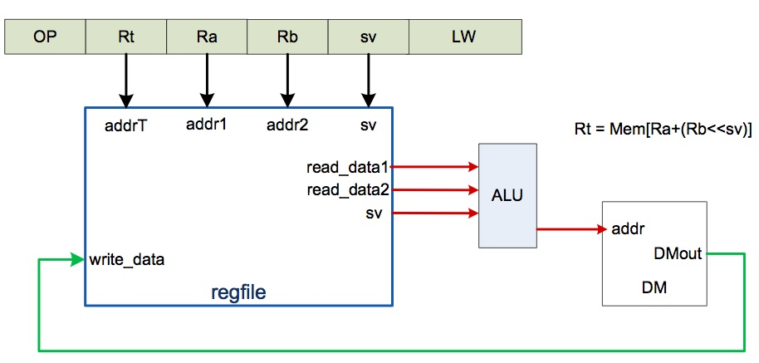

## SW

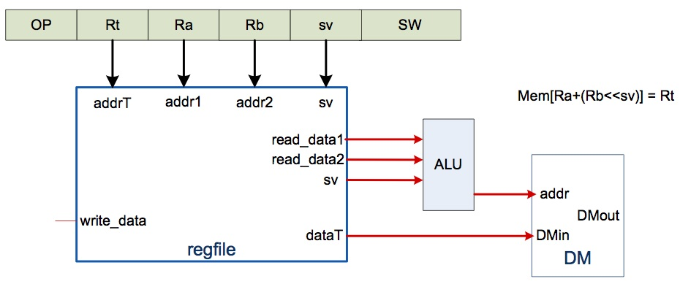

## BEQ

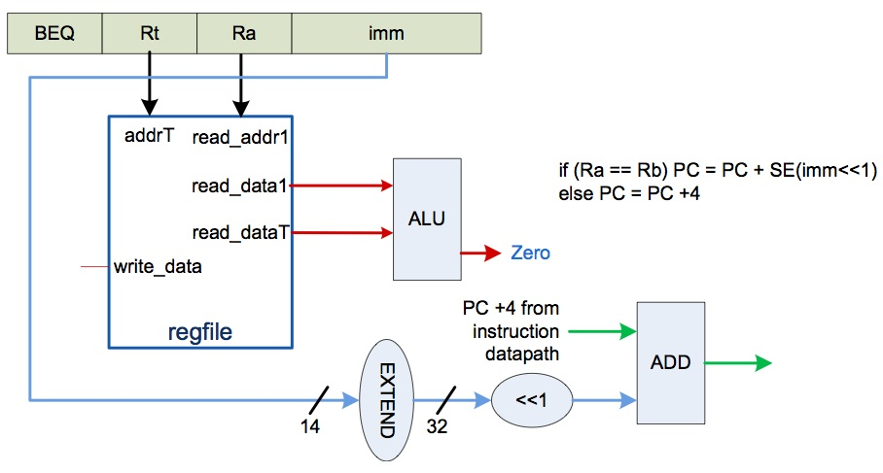

# Pre-simulated waveforms

## P5(a) mins.prog

* Recognize “end of program” and raise the “done” flag

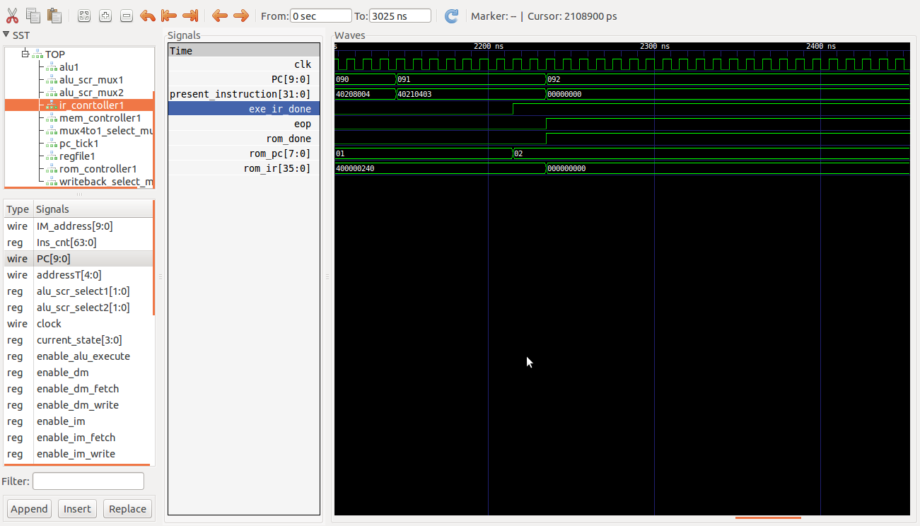

* R28=’h13=’d19
* R29=’h3=’d3
* (0) R0=20'd3 => R0 =’hD3

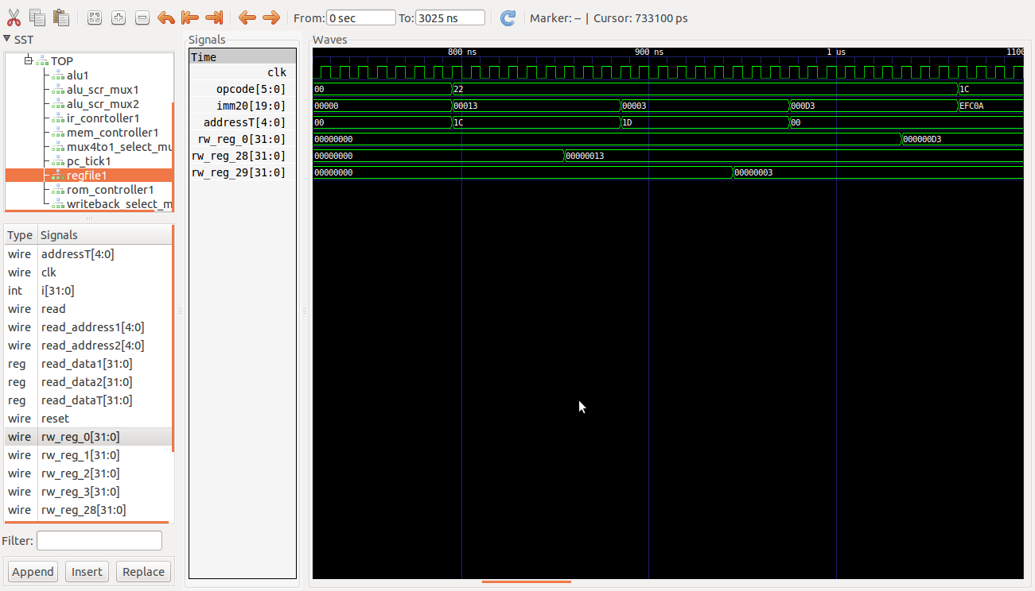

* (1) M3=R0 => M3=’hD3

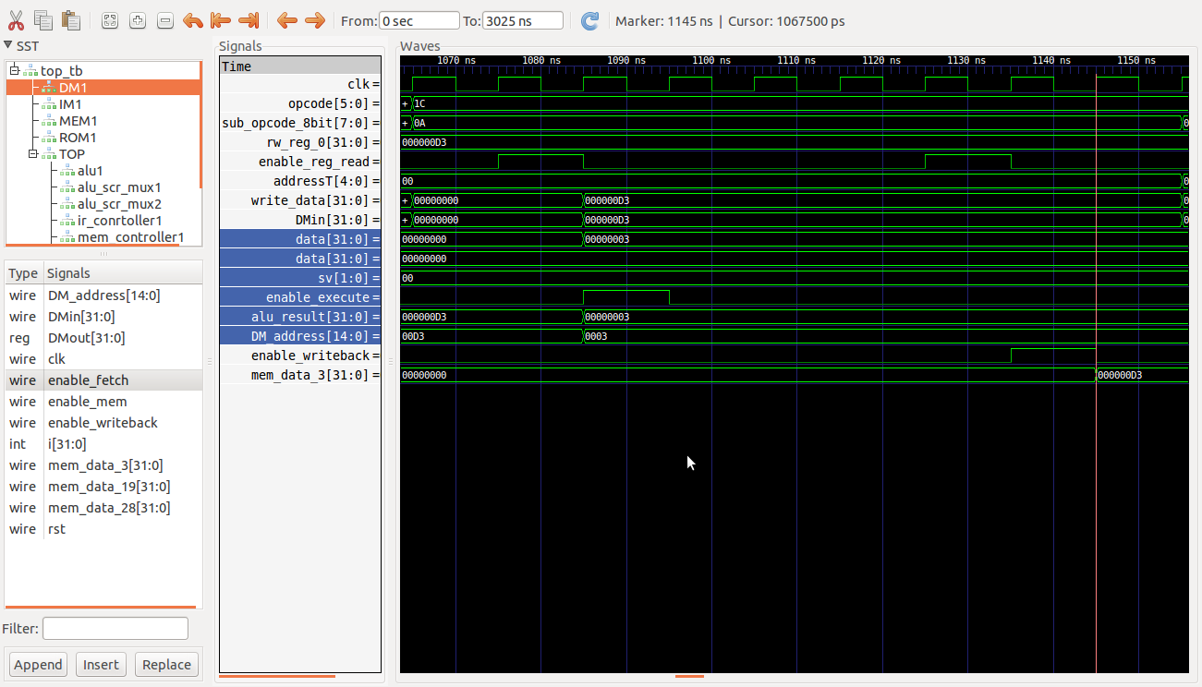

* (2) R1=M3 => R1=’hD3

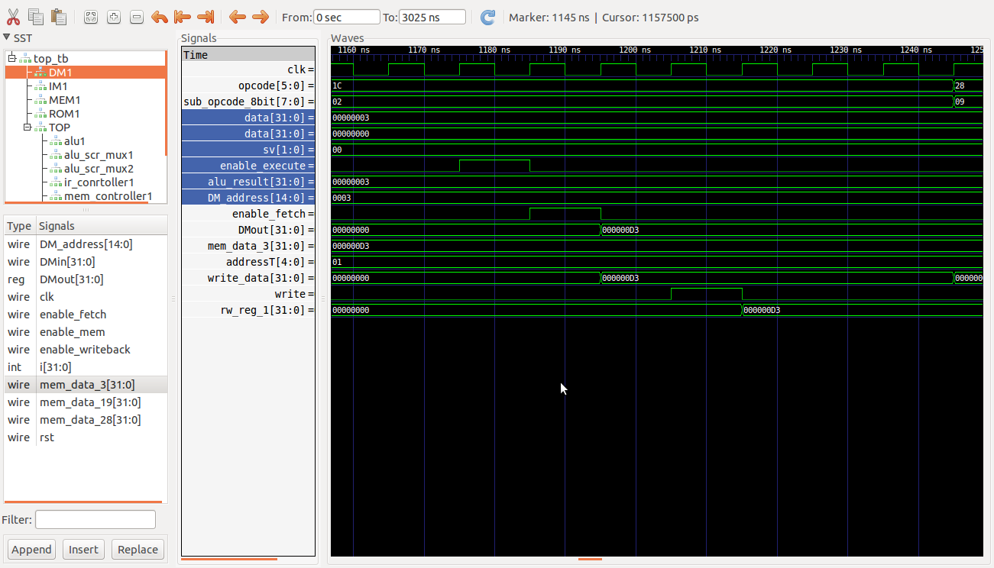

* (3) R1=R1+4’b1001 => R1=’hDC

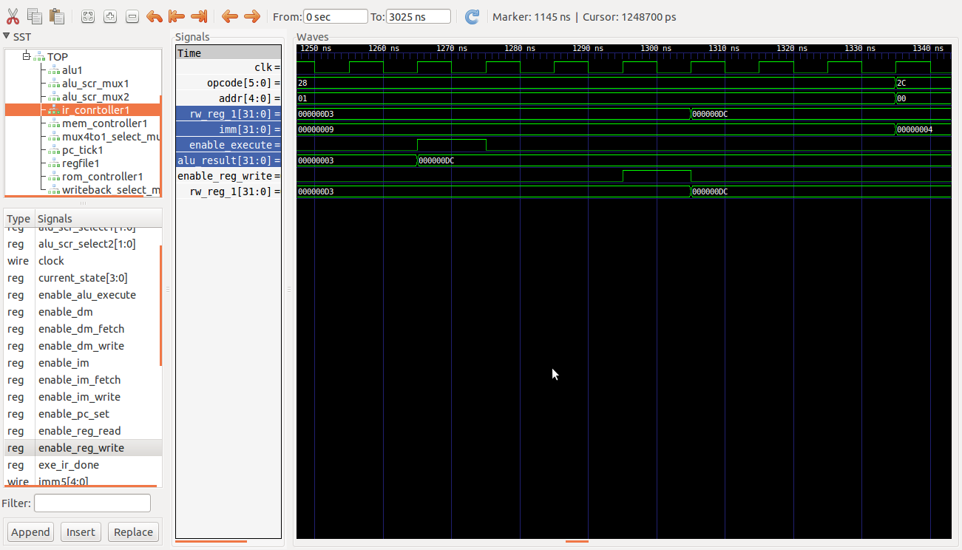

* (4) R0=R0|4'b0100 => R0=’hD7

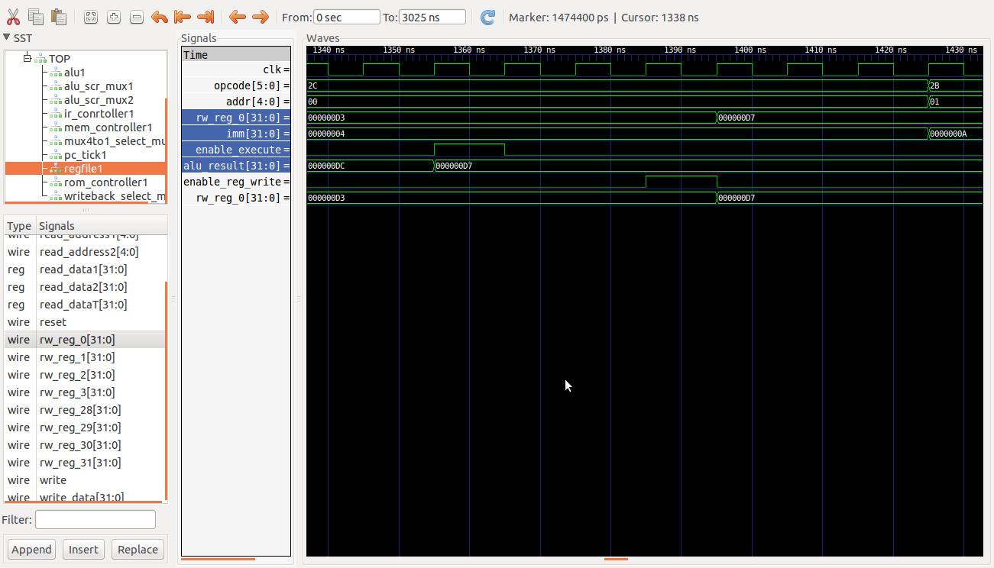

* (5) R1=R1^4’b1010 => R1=’hD6

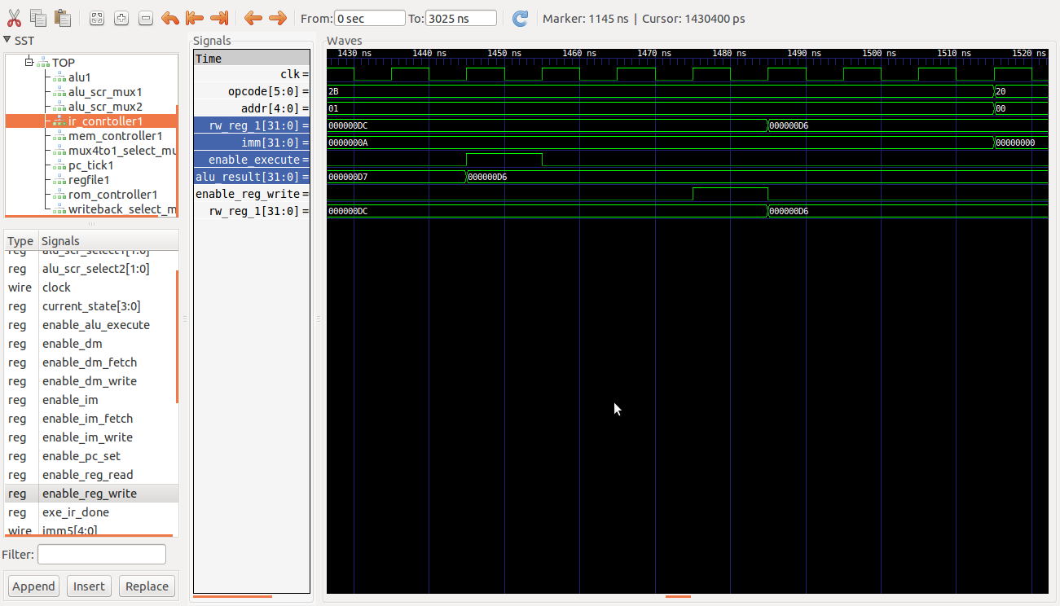

* (6) NOP
* (7) R1=R0+R1 => R1=’h1AD

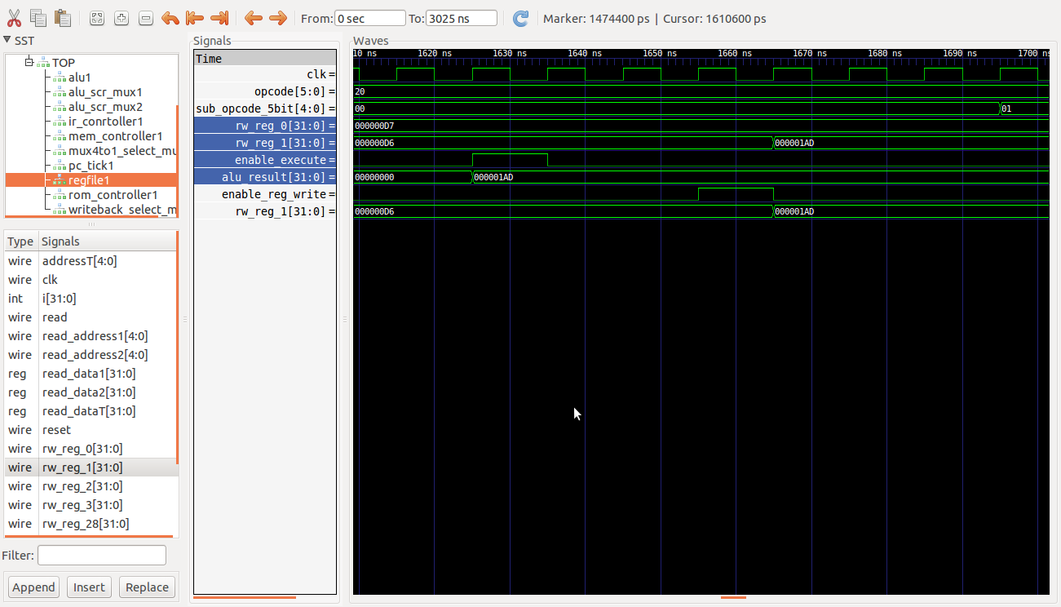

* (8) R1=R1-R0 => R1=’hD6

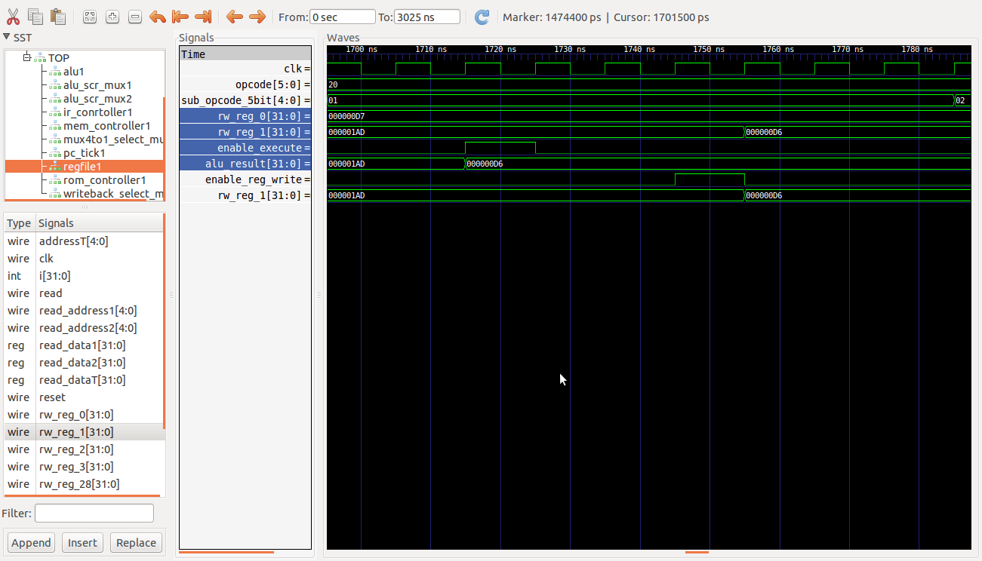

* (9) R1=R1&R0 => R1=’hD6

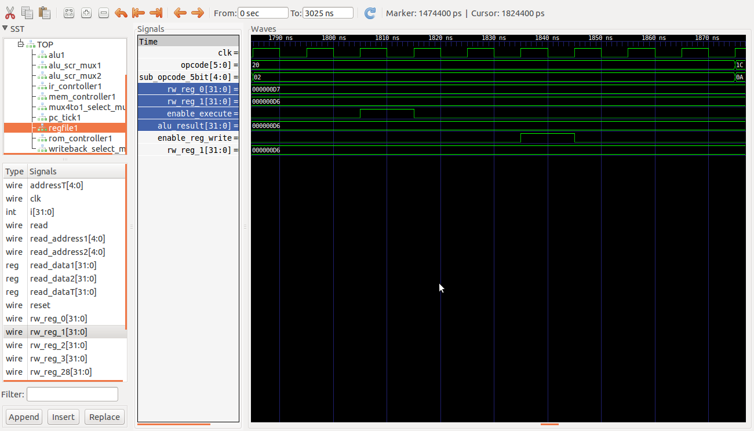

* (10) M19=R1 => M19=’hD6

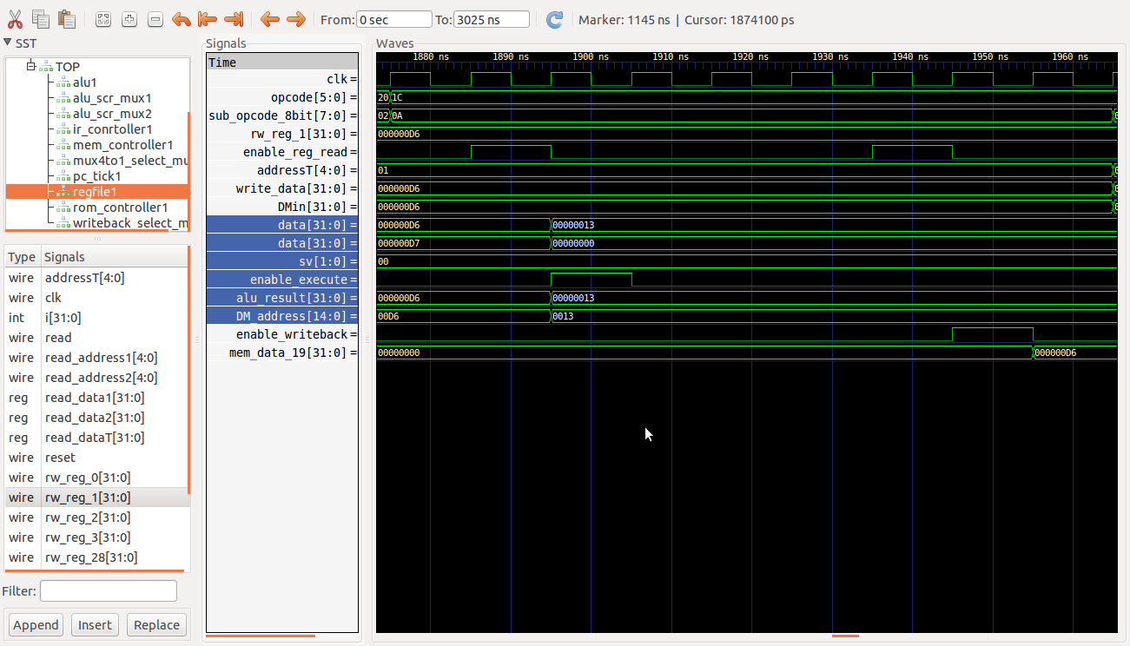

* (11) R2=M19 => R2=’hD6

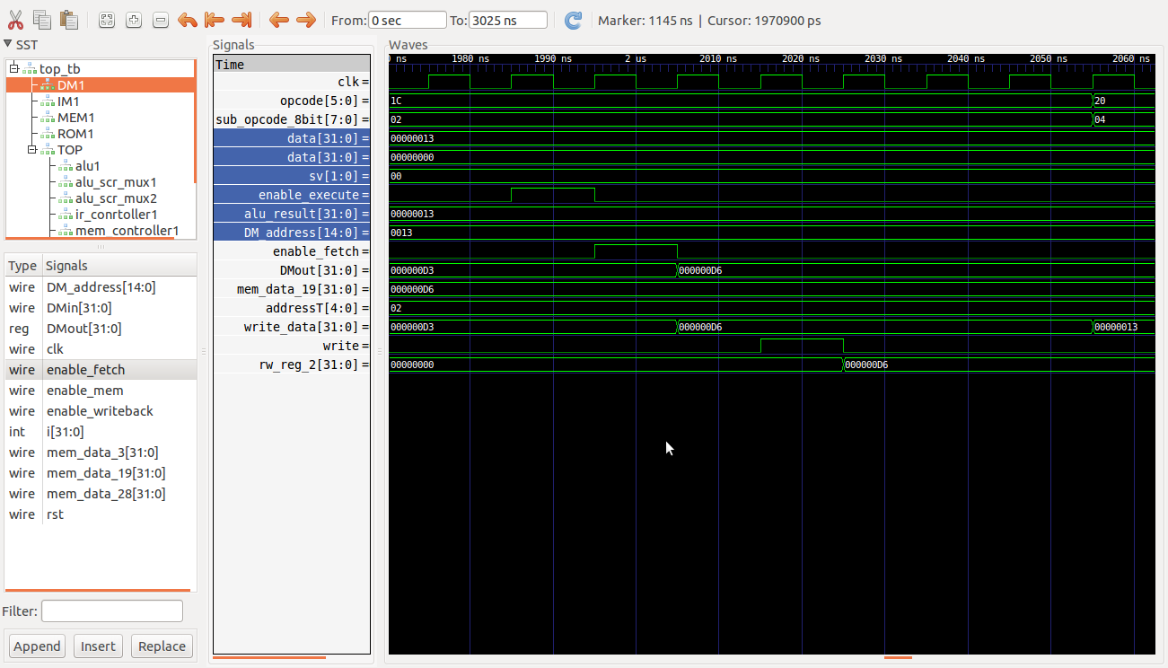

* (12) R2=R1|R0 => R2=’hD7

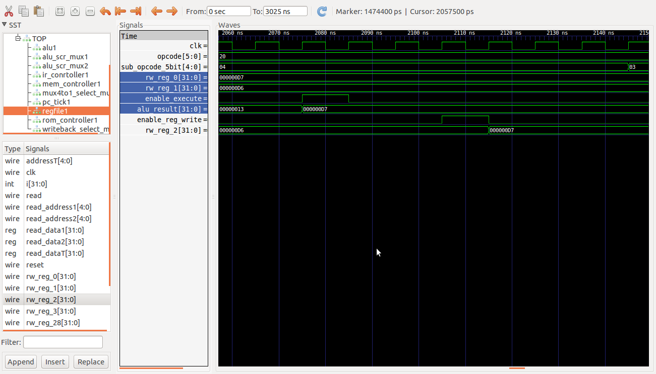

* (13) R2=R2^R1 => R2=’h1

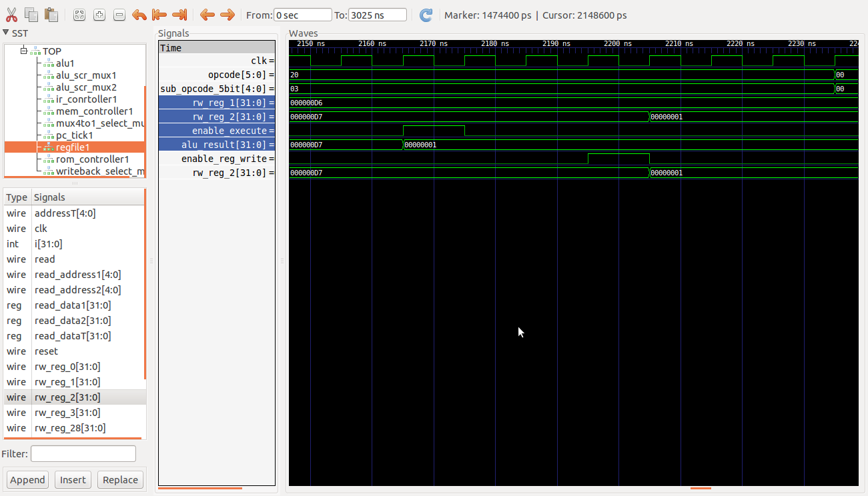

## P5(b) operations

### i. 130+760=890

MOVI (R1=d’130) => R1=’h82

ADDI (R0=R1+d’760) => R0=’h37A

SWI (M0=R0) => M0=’d890

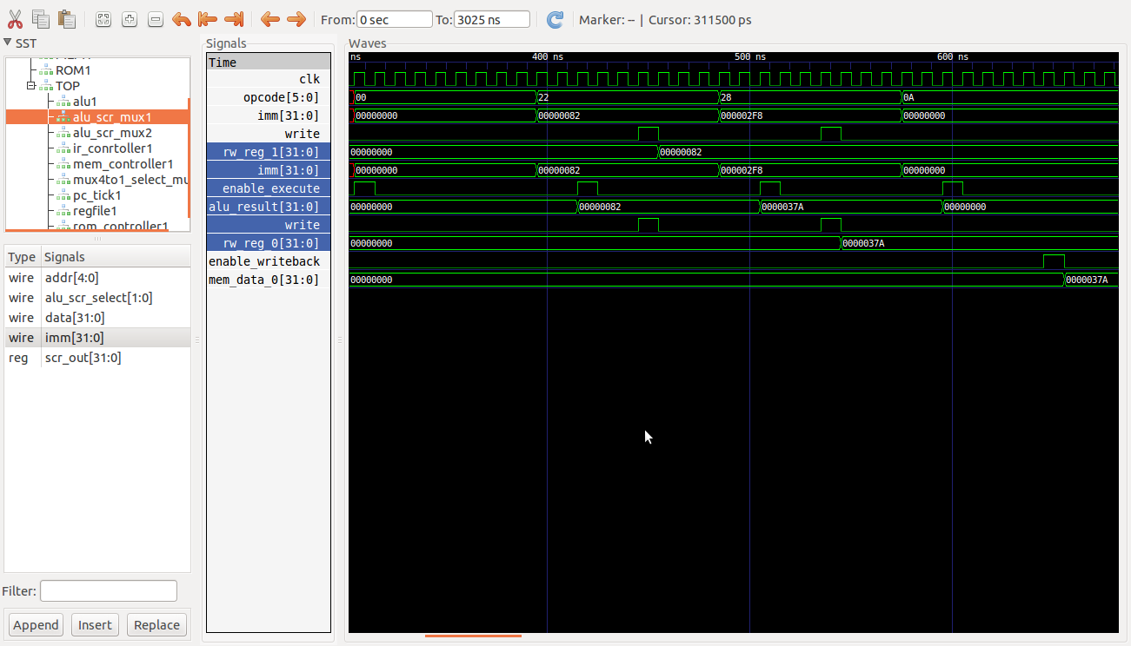

### ii. 1-65536=-65535

MOVI (R1=-d’65536) => R1=’hFFFF0000

ADDI (R0=R1+d’1) => R0=’hFFFF0001

SWI (M0=R0) => M0=-‘d65535

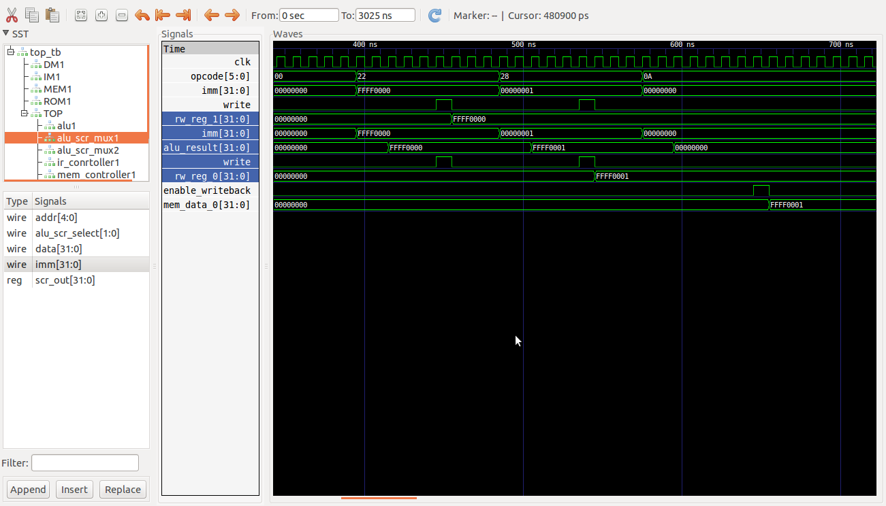

### iii. 255*(-7)=(-7)*28+7=-1785

MOVI (R1=-d’7) => R1=’hFFFFFFF9

SLLI (R1=R1<<8) => R1=’hFFFFF900

ADDI (R0=R1+d’7) => R0=’hFFFFF907

SWI (M0=R0) => M0=-‘d1785

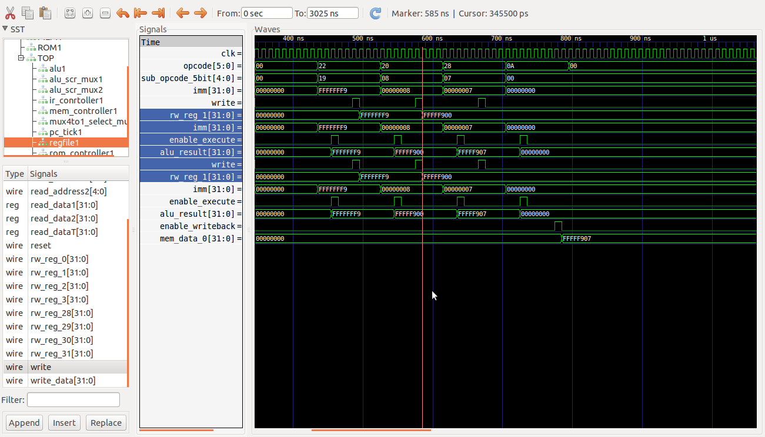

### iv. 40*2-160/4=40

MOVI (R1=d’40) => R1=h’28

MOVI (R2=d’160) => R2=h’A0

SLLI (R1=R1<<1) => R1=h’14

SRLI (R2=R2>>2) => R2=h’50

SUB (R0=R1-R2) => R0=h’28

SWI (M0=R0) => M0=d’40

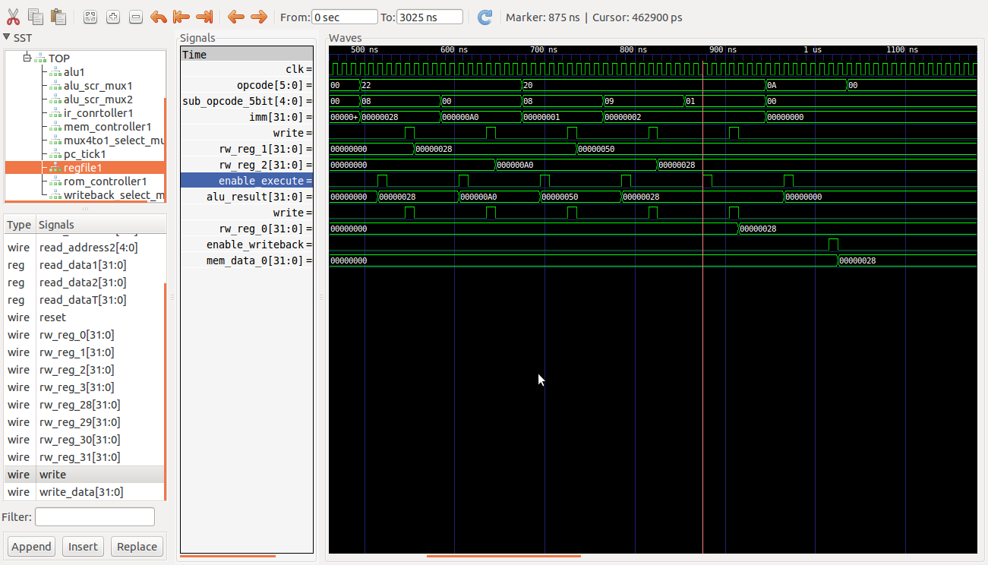

### v. Sort 5 arbitrary numbers in increasing order

Incomplete

## P6(a) mins1.prog

A=h’AA, B=h’F0, C=’hF, D=h’55

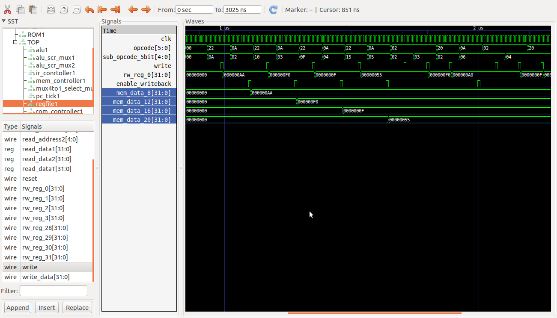

E=A&B=h’A0

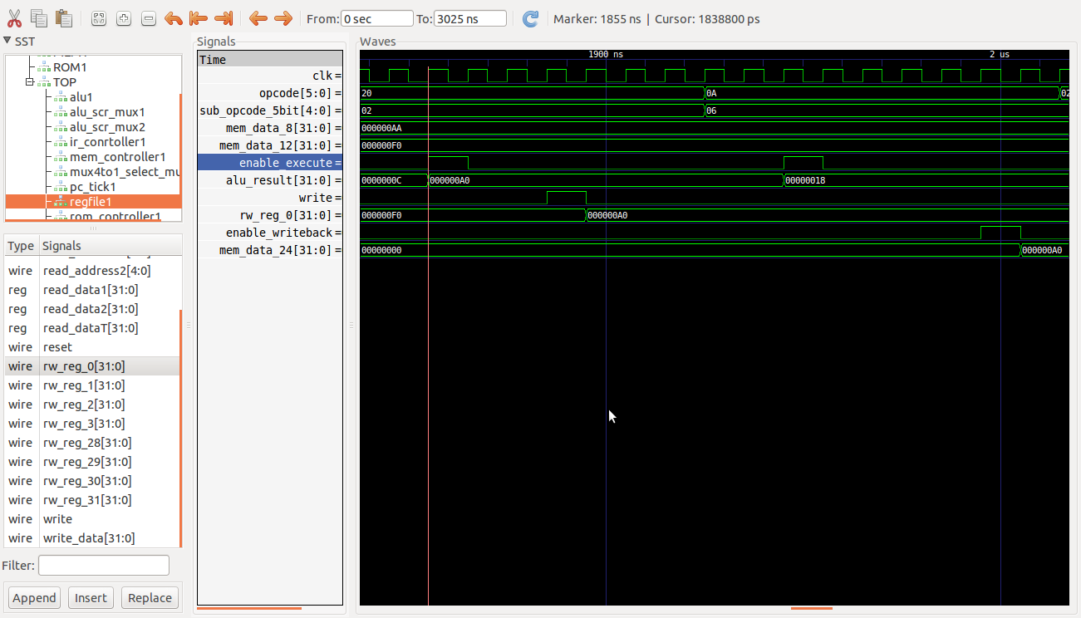

E=E|C=h’AF

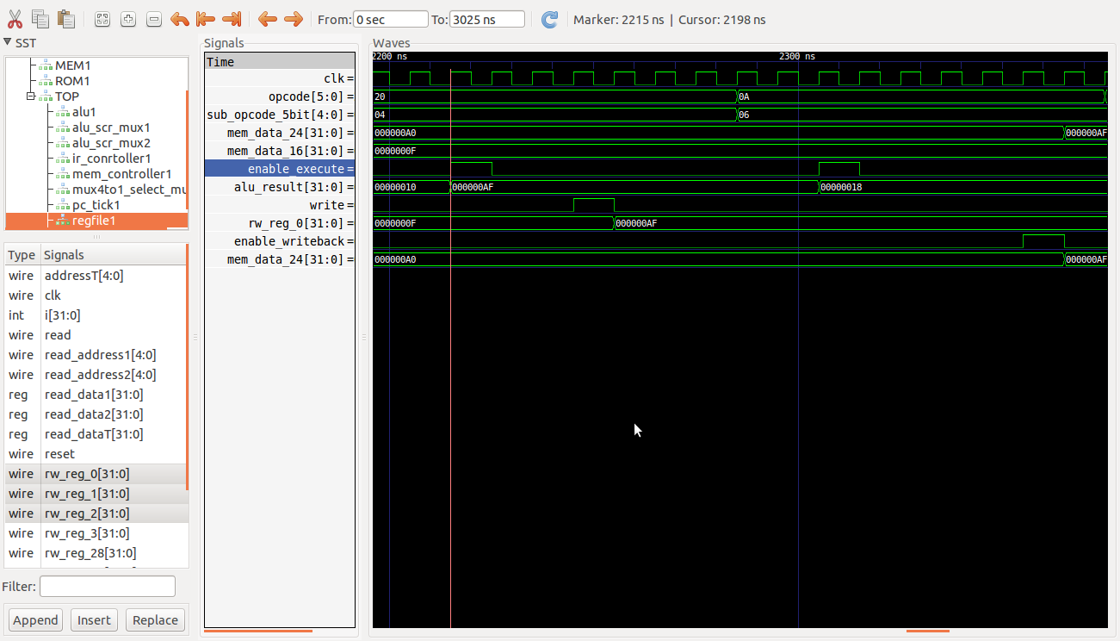

E=’hFA=’d250

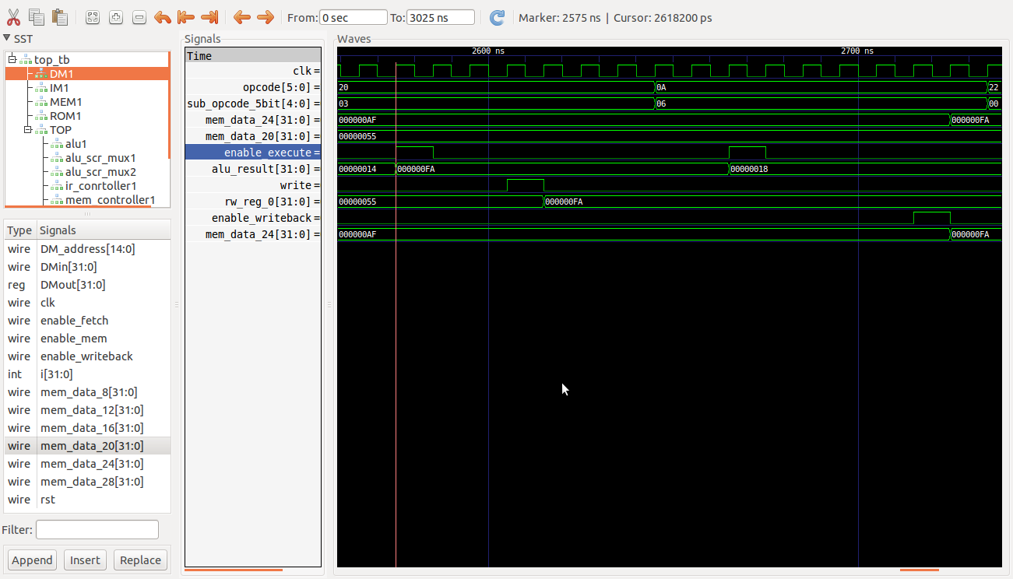

## P6(b) mins2.prog

L=’hFA, M=’hB8, N=’h137

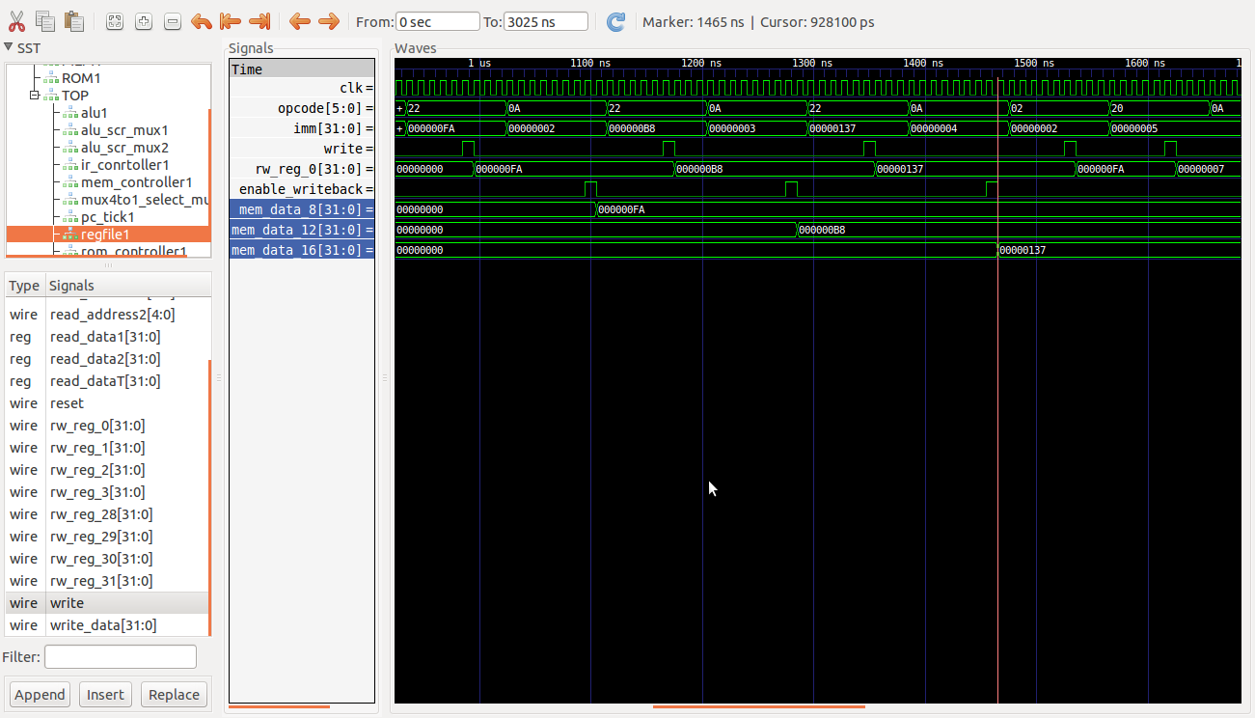

X=’h7=’d7

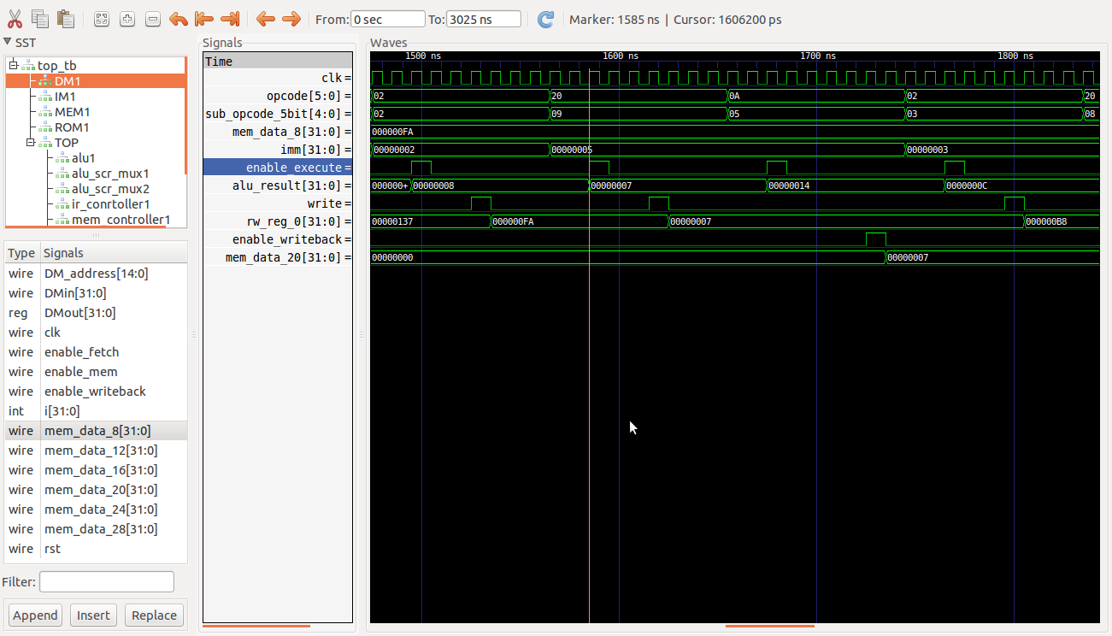

Y=’h5C0=’d1472

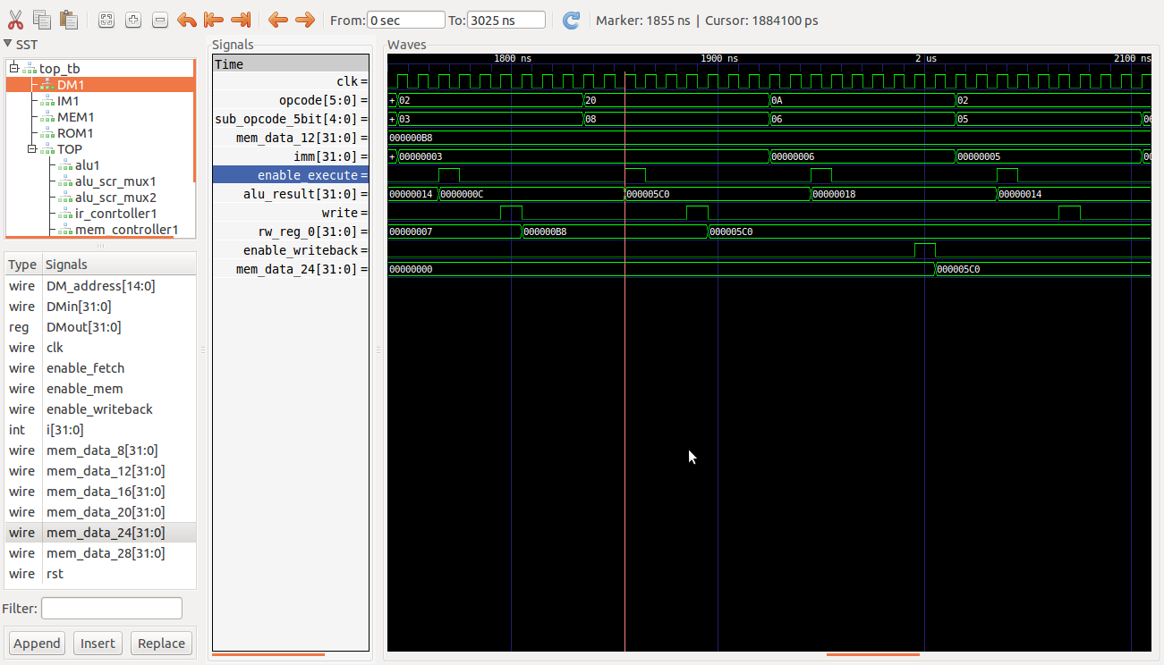

Z=X^Y=’h07^’hC0=’h5C7

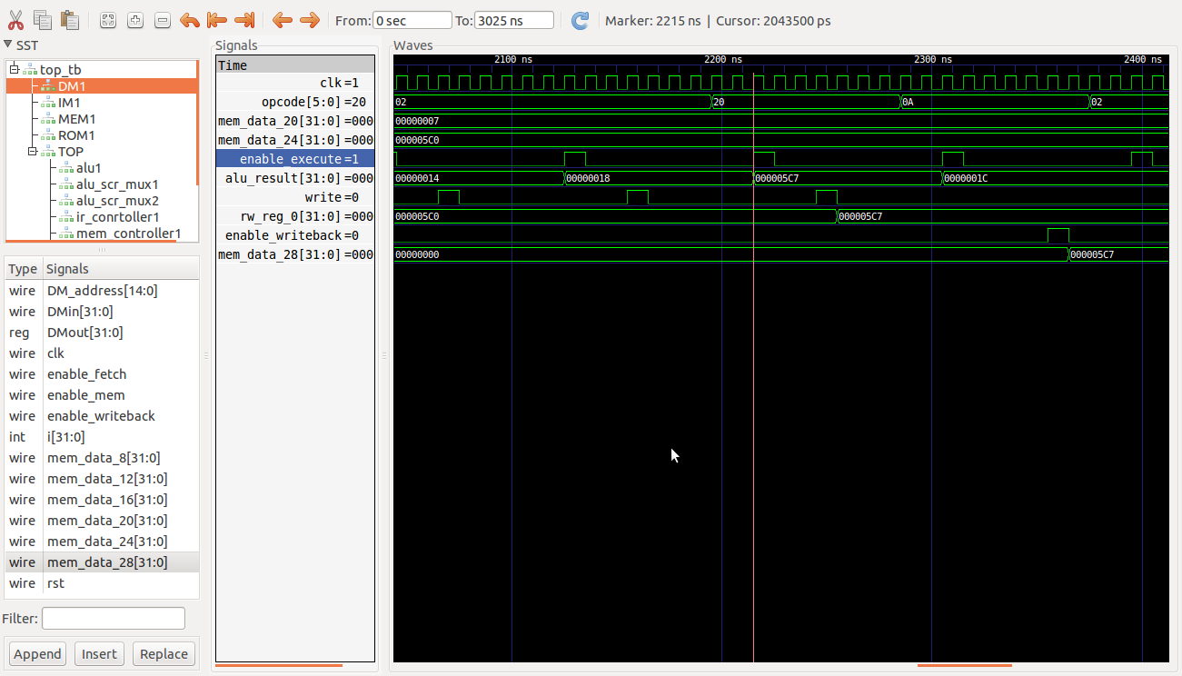

Z=Z|N=’h5C7|’h137=’h5F7=’d1527

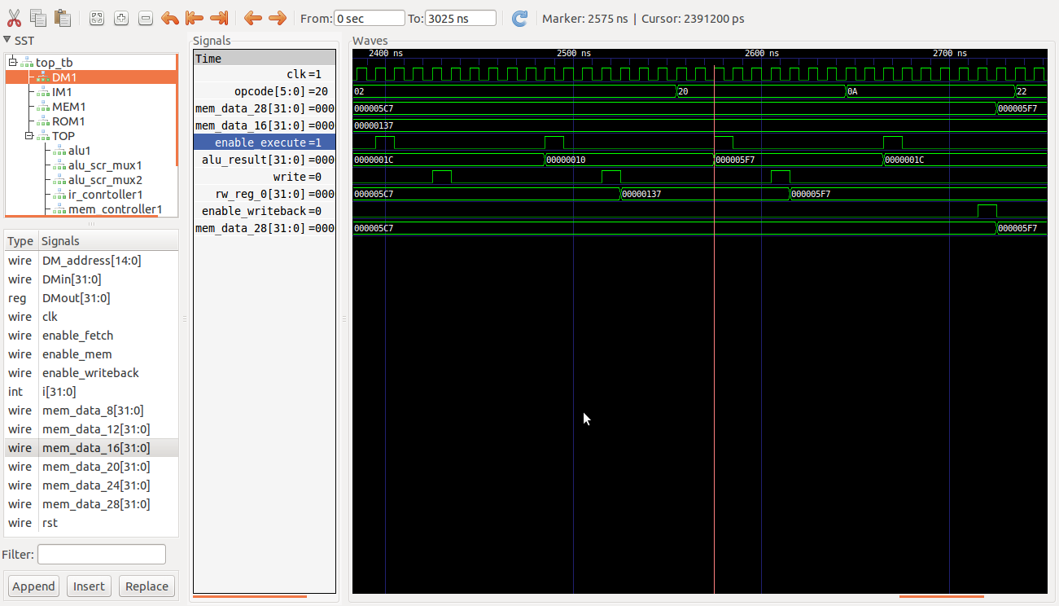

# nLint check

70 Warning(S), 22 Erros(s) in 2079 Line(s)

